1. Identify the following symbols:



Bulb Bulb Bulb Bulb

Cell (battery) Cell (battery) Cell (battery) Cell (battery)
Motor Motor Motor Motor
Switch Switch Switch Switch

2. Draw a diagram of the circuit pictured below, using the correct symbols:
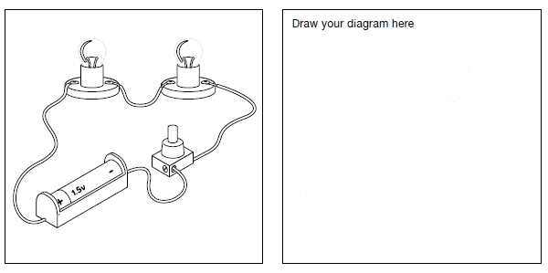

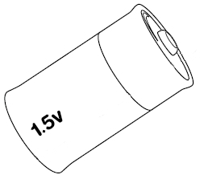
3. Look at the battery below: Indicate which is the positive end and which is the negative end.

Draw an arrow to show the direction that the electricity will flow through the battery.

What is the voltage of this battery? __________

4. Look at the circuit diagrams below. In the space underneath each circuit indicate whether or not you think the circuit will make the bulb light up and, if not, explain why?
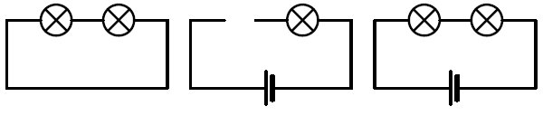

________________________________________________________________________

________________________________________________________________________
________________________________________________________________________

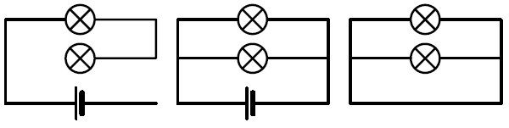

________________________________________________________________________
________________________________________________________________________
________________________________________________________________________

5. Why do we need electricity meters?
____________________________________________________________________________
____________________________________________________________________________

6. Why do we need a circuit breaker in a house?
____________________________________________________________________________
____________________________________________________________________________

7. What is a fuse?
________________________________________________________________________________________________________________________________________________________

